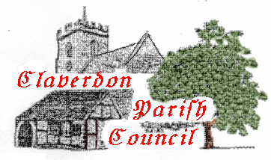PARISH COUNCIL OF CLAVERDON

AGENDA FOR PARISH COUNCIL MEETING 18th September 2023
Claverdon Church Centre
7pm
- Declaration of Interest
- Minutes of Meeting July’s 2023
- Matters Arising & Action Update
    - 3.1 Traffic Calming
    - 3.2 Bank Account Transfer
    - 3.3 Public Footpath Breach Lane
    - 3.4 Improving Planning Coordination
    - 3.5 Pavilion Water Meter
    - 3.6 Pavilion management progress
    - 3.7 FoYC management progress
- Public Forum
- Cllr. Duncan Parker
- Cllr. Ian Shenton
- Planning (Breach Lane Update)
- Portfolio Reports
- Communications
- Finance
- Recruitment
- A.O.B.

