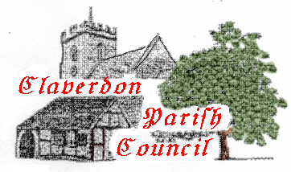PARISH COUNCIL OF CLAVERDON

AGENDA FOR PARISH COUNCIL MEETING 22nd January 2024
Claverdon Church Centre
7pm
- Declaration of Interest
- Vote in regard to Co-option of Sam Evans as a councillor
- Minutes of Meeting of November 2023
- Matters Arising & Action Update
    - 3.1 Pavilion legal - progress
    - 3.2 Pavilion hedges & gardening
    - 3.3 Crown ACV
    - 3.4 NHP Grant Funding
    - 3.5 Lye Green tree lopping - Ericson
    - 3.6 Lye Green tree audit
    - 3.7 Yarningale banking autonomy
    - 3.8 Yarningale Grit bin
    - Postbox St Michaels Road
- Cllr. Duncan Parker
- Cllr. Ian Shenton (may arrive after 8pm)
- Public Forum
- Cllr Roger Waring – Public Rights of Way Planning matters
- Neighbourhood Plan – Locality
- Biodiversity – Ian Bowater
- Portfolio Reports
    - Yarningale -Cllr. Fairlie
    - H & S – Cllr Spiers
    - Planning – Cllr Hilton
    - Communications – Cllr Hammond
    - Pavilion - appointment
- Finance & Precept
- Highways – Potholes
- AOB

