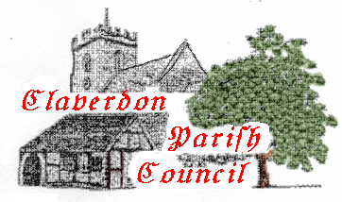PARISH COUNCIL OF CLAVERDON

AGENDA FOR PARISH COUNCIL MEETING 25th March 2024
Claverdon Church Centre
7pm
- Declaration of Interest
- Minutes of Meeting of January 2024
- Matters Arising & Action Update
    - 24.01 3.1.0 Pavilion legal - progress
    - 24.01.3.1.4 Lye Green tree
    - 24.01.3.1.9 Dog bin capacity/emptying
    - 24.01.4.1.2 Agenda posted on website in advance.
    - 24.01.8.0.7 Hercules Farm posting portal
    - 24.01.9.1.0 Byway slides to website
    - 24.01.11.1.0 Yarningale presentation to website
    - 24.01.13.1.0 Facebook
    - 24.01.14.1.0 Adrian Whitehouse liaison
    - 24.01.14.1.1 WALC course booking
- Public Forum
- Highways
    - (Steve Lister findings on Speed Monitoring & Reduction)
    - White gates
- Cllr. Ian Shenton
- Cllr. Duncan Parker
- Financial report
- Portfolio Reports
    - Yarningale -Cllr. Fairlie – including new salt boxes
    - H & S – Cllr Spiers
    - Planning – Cllr Hilton
    - Communications – Cllr Hammond
    - Pavilion
- AOB
    - Cllr. Dargan Henley SWDP update
    - Telephone box progress & Royal Mail post-box
    - Councillor recruitment

